EasyEDA Professional Certification Exam Instructions
1. Exam Platform
- Practical Test (100 points)
- Software Environment: EasyEDA Professional (Web Version)
- Exam Duration: 240 minutes
2. Exam Tasks (Practical Test)
2.1 Project Creation
Please refer to the attachments for the exam workspace and instructions.
Log in to the Easy EDA account, participate in the exam in the designated exam workspace, and create an exam project.
Name the exam project as: GD32-based Temperature and Humidity Detection Board + your own customer number (e.g.: GD32-based Temperature and Humidity Detection Board + 123456A).
Note that the name of the exam project must follow the format: GD32-based Temperature and Humidity Detection Board + your own customer number.
Otherwise, it will be scored 0.
2.2 Schematic Design
Using the provided schematic PDF and BOM file, complete the component selection and schematic drawing.
Requirements:
- All components must be selected and placed according to the BOM designators and part numbers.
- The wiring layout must match the provided schematic without significant deviation.
- Network identifiers and net labels must follow the given schematic and cannot be modified.
- After completing the schematic, ensure the design rule check (DRC) shows no warnings or errors.
-Devices such as resistors/capacitors display relevant attribute information according to the schematic PDF.
-The symbol of the temperature and humidity sensor AHT20 (product number: C2757850) needs to be modified according to the provided schematic.
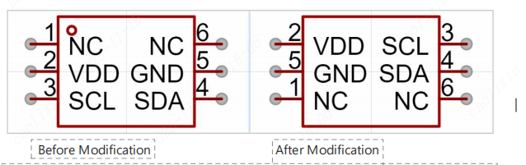
2.3 PCB Design
After the schematic is completed, update it to generate the PCB file.
Complete the component placement and routing with the following requirements.
(1) Design Rules
Safety Spacing：For copper Thickness1oz, the minimum clearance between wires is set to 6mil.
Wire Width：For copper Thickness1oz, the minimum wire width is updated to 8mil.
Power Net Rule：Add power network rule: name POWER; width 15mil (min 10mil, max 25mil)
Apply to VBUS, +5V, +3V3, GND.
(2) Board Outline
- Draw a 70mm × 30mm rectangle, wire width 10mil.
- Origin at bottom-left corner.
- Fillet radius: 2mm
- Lock after drawing.
(3) Component Layout
(All components must be on top layer; otherwise 0 points.)
- M3 Screw Holes:
SCREW1: (3mm, 27mm)
SCREW2: (67mm, 27mm)
SCREW3: (3mm, 3mm)
SCREW4: (67mm, 3mm)
(All locked)
- Type-C: (4.6mm, 15mm), rotation 270°, locked
- OLED Screen: (35mm, 27mm), rotation 0°, locked
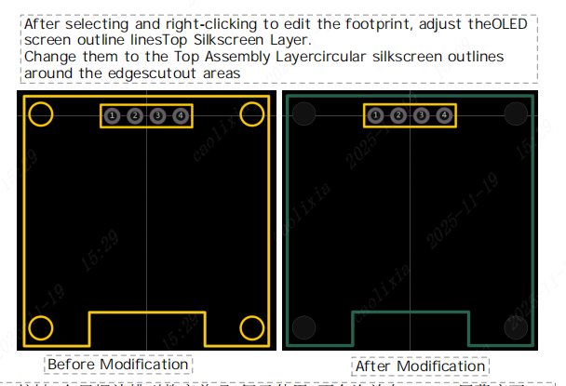
- Buttons: Neat, easy to use, not under OLED
- LEDs: Neat, easy to view, not under OLED
- AHT20 Sensor: Reasonable placement to ensure accuracy
- Pin Header Download Interface: Clear silkscreen, reasonable placement
- General Layout: Compact, neat, consistent density
(4)Routing Design
Notes: The PCB must pass DRC checks with no errors, otherwise it will be scored 0! Complete the PCB routing within the specified board outline according to the following requirements:
Number of routing layers: 2 layers
Minimum trace width: Signal traces ≥ 8mil, power traces ≥ 15mil (can be reduced locally to 10mil)
Crystal oscillator network: Place the crystal as close as possible to the MCU, avoid positioning it at the board edge. Keep traces as short and straight as possible, avoid routing on the bottom layer, and apply top-layer ground clearance.
Character silkscreen: Use Arial for English text, height ≥ 1.2mm
Character layer: Top silkscreen layer; text must be neatly arranged, and interface areas should include label indicators
Teardrops: Add teardrops in circular or linear shapes to improve connection reliability
Copper pours: Top and bottom layers should be filled with GND net copper, ensuring the integrity of the GND copper plane
Net connectivity: 100%
General routing: Avoid right angles and acute angles; maintain consistent corner styles. Overall routing should be neat and visually appealing
3. Submission Instructions
Save your project before the exam deadline.
After the deadline, the system will no longer allow saving.
Please save frequently during the exam.
4. Additional Notes
If you encounter any issues during the exam, please contact selina@easyeda.com immediately.
Please complete the exam honestly. A score of 70 or above is required to pass and receive the certificate.

